Chapter 1

Collision Theory
Rate of reaction is determined by the number of successful collisions in a given time.
Greater number of successful collisions = to faster rate of reaction.

States that for a reaction to occur:
- Reacting particles must collide
- Collision energy must equal or exceed activation energy (Ea)
- Must collide with suitable orientation (Transition State)

Factors affecting reaction rate
- Concentration/partial pressure: if concentration of a reactant is increased, then there will be more particles in a given volume. Makes it more likely for reactant particles to collide, therefore more collisions. *Only for reactants in solution or gaseous phase.
- Pressure: pressure of a gas is due to force exerted by particles colliding with the walls of the container. An increase in pressure means more particles in a given volume. Thus, concentration of gas particles will increase and therefore more collisions between particles. Reverse happens at decrease of pressure.
- Temperature: Increased temperature means increased average kinetic energy. This means more particles will have sufficient energy for a successful collision. Increased kinetic energy associated with increased speed of particles, thus more frequent collisions.
- Surface Area: In solids, only exterior of particles can collide. If surface area is increased by division or crushing, more particles will be exposed and be available for collision.
- Catalysts: Provide an alternative, easier pathway for reaction. This means lower activation energy, so more particles will have sufficient energy for a successful collision.
- Nature of Reactants: Ionic reactions are rapid as they do not involve the breaking of bonds or electron transfer between reacting particles. Molecular reactions are slow since they involve breaking and bond formation. Collisions are often unsuccessful at room temperature due to insufficient activation energy.

Energy Changes
Exothermic:
- Loses heat to surroundings.
- There is a negative change in enthalpy.
- Some of the chemical potential energy stored in bonds is converted to particle kinetic energy. Causes increase in system’s temperature.
- Overall energy is conserved with chemical potential energy becoming ‘heat’ energy.

Endothermic:
- Gains heat from surroundings.
- There is a positive change in enthalpy.
- Fall in temperature due to particle kinetic energy converted to chemical potential energy.
- Initially there is no change in enthalpy.

Chapter 2

Reversible Reactions
- Have a low activation energy for forward and reverse reaction
- Don’t go to completion as once the products form they react to reform reactants
- In closed systems, forward & reverse reactions compete with 1 another preventing the reaction from completing in either direction

Equilibriums
Properties:
- Reversible
- Dynamic
- Macroscopic properties are constant (colour, pressure, temperature)

Physical Equilibrium
Example: Water
H₂O_{(l)} ⇄ H₂O_{(g)}
- In a closed system, the vapor is unable to escape so it reverts back to a liquid. Therefore a reversible reaction.
- Initially, the forward reaction dominates the reverse.
- However, as vapor concentration increases; the rate of vapour condensation also increases until they are equal. The rate of condensation = rate of evaporation.
See Fig 1.

Chemical Equilibrium
Example:
2NO_{2(g)} ⇄ N₂O_{4(g)} Change in Enthalpy: -57kJ
(brown) (colourless)

- In a closed system, NO₂ ‘s molecules will combine to form N₂O₄ molecules.
- Overtime this reduces NO₂’s concentration, hence reducing rate of reaction.
- As N₂O₄ begins to form, it can decompose into NO₂.
- This results to both their concentrations are such that the reaction reaches equilibrium.

Equilibrium Position
- Relative concentration of reactants to products is different for different systems.
- Equilibrium constant, Kc gives a numerical value relating concentration of all species in a system at Equilibrium.

Equilibrium constant expression:
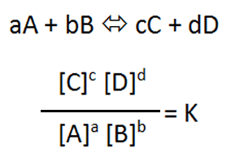
- Square brackets as an abbreviation for concentration.

- Only aqueous and gases appear in expression. Solids and liquids have a fixed concentration
- Kc has no units
- Kc has a constant value for all conditions of concentration and pressure
- Kc changes with temperature
- Kc is always positive

- Kc>1 : reaction favours products
- Kc >>1 (eg 10³) : reaction very strongly favours products
- Kc<1 : reaction favours reactants
- Kc<<1 (eg 10⁻³) : reaction very strongly favours reactants
- Values close to 1 imply equal of both reactants and products
*Water is always neutral

Reaction quotient expression:
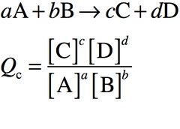
- For a system not necessarily at equilibrium
- If Qc=Kc then system is at equilibrium

Shifting the equilibrium position
A chemical equilibrium system can return to a state of equilibrium after alterations (imposed changes)
Imposed changes:
- Concentrations of any 1 species (removing or adding)
- Total pressure in gaseous system (raising/lowering volume)
- Temperature of system (add/remove heat from system)

Le Chatelier’s Principle
“If a change in conditions is made to a chemical system in equilibrium, then the system will adjust in such a way as to partially counteract the imposed change.”

Effect of changing concentration
Example: In a system at equilibrium, more of a particular substance is added. This increases concentration of substance and rate of reaction.
PCl_{3(g)} + Cl_{2(g)} ⇄ PCl_{5(g)}
- More Cl₂ is added.
- Forward reaction rate increases
- Reverse initially not affected
- As more PCl₅ is produced however, the reverse reaction rate increases
- A new equilibrium is eventually reached with identical new forward and reverse reaction rates
Explanation:
- If the concentration of reaction is increased, then the forward reaction also increases
- Overtime the concentration of reactants reduces as they are temporarily used faster than produced
- There is also an increase in concentration of product as it is temporarily produced faster than used.
- Forward reaction rate slowly decreases as fall in reactant concentration and collision rates.
- Reverse reaction rate slowly increases.
- Concentration changes continue until rate of forward = rate of reverse.
- Therefore there is a partial reduction and a new equilibrium is formed.
*In aqueous solutions, adding water decreases concentration of all aqueous substances. The reaction creating the most aqueous molecules is then favoured.
See Fig 2. & 3.

Changing the total pressure
If a container volume is altered, then the total pressure is changed.
- Increase in volume = decrease in total pressure.
- Decrease in volume = increase in total pressure.
- Less molecules = less pressure
Le Chatelier’s principle states that the equilibrium will re-establish itself to minimise pressure change by altering total moles of gas present.
- Increasing pressure favours equilibrium reaction side with fewer moles of gas.
- Fewer moles of gas means less pressure within system, thus partially counteracting imposed change
- Eg: if less moles in reactants then that is favoured.
- Decreasing pressure favours equilibrium reaction side with the greater moles of gas.
- More moles of gas means more pressure, thus partially counteracting imposed change.

*If both sides have same number of moles of gas then changing the pressure has no effect on equilibrium position.
*Adding an inert gas has no effect.
*Changing pressure by selectively adding or removing 1 of the gaseous reactants or products is equivalent to altering the concentration only.
See Fig 4.

Temperature change
If temperature of system at equilibrium is altered, the system changes to minimise temperature change.
- Increase in temperature: favour in endothermic process. System converts added heat to chemical potential energy. This causes temperature to fall.
- Decrease in temperature: favour in exothermic process. Converts chemical potential energy to heat. Causes temperature to rise.
Explanation:
Collision theory states a temperature rise will increase average particle collision energy and reaction rate.
However endothermic reaction rates are much more sensitive to temperature change than exothermic.
So raising temperature in equilibrium, the rate of endothermic reaction increases more than exothermic reaction.

Therefore…
Increasing temperature lowers endothermic reaction rate more than exothermic
- This is why increasing temperature favours endothermic and decreasing temperature favours exothermic.
Also: changing temperature causes a change in the value of Kc.
- In endothermic, Kc increases as temperature increases.
- In exothermic, Kc decreases as temperature increases.

Other Alterations
- Catalysts have no effect on equilibrium position
- Catalysts will speed up rate of attainment of equilibrium. → due to catalyst increasing both forward and reverse equally.
Removal of reactants and products present as a solid or liquid doesn’t alter equilibrium concentration or amount of any other species (Due to their fixed concentration)

Chapter 3
Physical Properties

Acids | Bases
Conduct electric current | Conduct electric current
Turn blue litmus red | Turn red litmus blue
Sour taste | Bitter taste
 | Slippery soapy feel

Chemical properties:

Acid + Metal → Salt + H_{2(g)}

Acid + Metal Hydroxide → Salt + H₂O

Acid + Metal Oxide → Salt + H₂O

Acid + Carbonate → Salt + H₂O + CO_{2(g)}

Acid + Hydrogen Carbonate → Salt + H₂O + CO_{2(g)}

Acid + Metal Sulfite → Salt + H₂O + SO_{2(g)}

Base + Ammonium Salt → Salt + H₂O + NH_{3(g)}

Base + Non-metal Oxide → Salt + H₂O

Chapter 4

Strong Acids | Strong Bases
Hydrochloric acid, HCl  Nitric Acid, HNO₃  Sulfuric Acid, H₂SO₄ | Sodium Hydroxide, NaOH  Potassium Hydroxide, KOH  Barium Hydroxide, Ba(OH)₂  Sodium Oxide, Na₂O
Weak Acids | Weak Bases
Ethanoic acid, CH₃COOH  Carbonic acid, H₂CO₃  Hydrofluoric acid, HF  Citric acid, C₆H₈O₇ | Ammonia, NH₃  Methylamine, CN₃NH₂

Concentration
Strong acid completely ionised in aqueous solution thus producing a higher H⁺ concentration than a weak acid which only partially ionises in aqueous solution. Thus strong acid produces highest H⁺ concentration for same acid concentration.

Arrhenius Theory
Acids:
An acid will ionise and produces H⁺ ions when dissolved in water.
HCl_{(g)} → H⁺_{(aq)}+ Cl⁻_{(aq)}
Bases:
A base will dissociate and produces OH⁻ ions when dissolved in water.
NaOH_{(s)} → Na⁺_{(aq)} + OH⁻_{(aq)}
- Theory is limited as it only applies to acid-base behaviour in aqueous solutions.
- Does not explain or predict basic nature of other compounds such as carbonates and oxides or salts.
- None of which contain OH⁻.

Bronsted-Lowry Theory
Explains acid base behaviour in terms of proton transfer between 2 species. Classifies substances as acids or bases in the context of a given reaction.
- An acid acts as a proton (H⁺) donor
HCl_{(g)}+H₂O_{(l)} ⇌ H₃O⁺_{(aq)} + Cl⁻_{(aq)}
Acid Base Hydronium Ion
^{Conjugate Acid Conjugate Base}
- A base acts as a proton (H⁺) acceptor
NH₃ + H₂O_{(l)} ⇌ NH₄⁺_{(aq)} + OH⁻_{(aq)}
Base Acid Conjugate acid Conjugate base
Bronsted-Lowry proton transfer reaction requires both an acid and base to be present for a reaction to occur. In this case, water is behaving as an acid.

Conjugate Acids and Bases
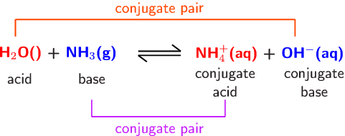
- When an acid donates a proton, what is left behind is its conjugate base.
- When a base accepts a proton, the substance formed is its conjugate acid.

Acidity Constant K_{a} and Acid Strength
A numerical measure of the extent to which the proton transfer reaction goes to completion, an indicator of acid strength.

HA_{(aq)} + H₂O_{(l)} ⇌ H₃O⁺_{(aq)} + A⁻_{(aq)}

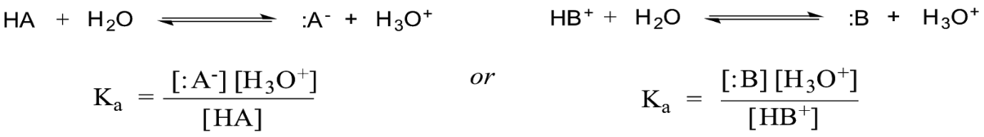
- H₂O has a fixed concentration, so it is not included.
- Proton transfer equation is for the transfer of a single proton.
- Large K_{a}, greater tendency for acid to donate proton to water. Therefore stronger acid and greater degree of its ionisation.
- Small K_{a} means weak acid.
- While it indicates strength of acid, it also indicates strength of conjugate base to accept proton back from water.
- If K_{a} is very large then the conjugate base is extremely weak (possible neutral).
- As K_{a} is progressively smaller and the acid progressively weaker, the conjugate base becomes progressively stronger.

Polyprotic Acids
Acids like HCl are said to be monoprotic, can only donate 1 proton per acid molecule.
Polyprotic acids are able to donate more than 1 proton per molecule of acid:
Diprotic has 2 acidic hydrogen atoms, eg: H₂SO₄.
Triprotic has 3 acidic hydrogen atoms, eg: H₃PO₄.
- The conjugate base of a polyprotic acid is usually acidic in relation to water. However its acid strength is always less than the original acid.
H₂SO_{4(aq)} + H₂O_{(l)} ⇌ H₃O⁺_{(aq)} + HSO₄⁻_{(aq)} -first proton transfer, K_{a} approx. 10⁹
HSO₄⁻_{(aq)} + H₂O_{(l)} ⇌ H₃O⁺_{(aq)} + SO₄²⁻_{(aq)} -2nd proton transfer, K_{a} = 1.0x10⁻²
- Subsequent acidity constants decrease with each proton transfer. Due to each subsequent conjugate base of original acid having an increasingly negative charge making it harder to donate a hydrogen ion (positive).

Acid-base Properties of Salts
In an acid-base reaction, the salt formed is not always neutral.
Acidic or basic salts arise from the hydrolysis (reaction with water) reactions of cations/anions derived from the weak acid or base.
If one of the ions present in a salt reacts with water acting as a proton donor (acid), then solutions will be acidic.
Eg: Ammonium, a weak acid.
NH₄⁺ + H₂O ⇌ H₃O⁺ + NH₃
Formation of H₃O⁺ gives an acidic solution.
 | Strong Base | Weak Base
Strong Acid | Neutral salt | Acidic Salt
Weak Acid | Basic salt | Neutral salt

Cations (+)
Acidic | Neutral | Basic
NH₄⁺ | The Rest | None
Fe³⁺
Al³⁺

Anions (-)

Acidic | Neutral | Basic
H₂PO₄⁻ | Cl⁻ | The rest
HSO₄⁻ | Br⁻
 | I⁻
 | NO₃⁻

K_{w} and the autoionisation of water
Some H₂O (extremely small) change into H⁺ and OH⁻ ions.
- The ions are produced in equal numbers by a reversible reaction known as autoionisation or self-ionisation.

H₂O_{(l)} ⇌ H⁺_{(aq)} + OH⁻_{(aq)} OR 2H₂O_{(l)} ⇌ H₃O⁺_{(aq)} + OH⁻_{(aq)}
- Both ions have the same extremely low concentration: 1.0x10⁻⁷ mol L⁻¹ at 25C.
- therefore conc of ions is so low that the conductivity of pure water is negligible.
- In water or any solution with the same concentration as H and OH, it is neutral.
- If extra H or OH is added the equilibrium will re-establish a new equilibrium. Adding acid to water raises H concentration and lowers OH concentration.
Equilibrium expression for self-ionisation of water; k_{w}:

H₂O_{(l)} ⇌ H⁺_{(aq)} + OH⁻_{(aq)} Change in Enthalpy = 55.8kJ
K_{w} = [H⁺][OH⁻] = 1x10⁻¹⁴ also K_{w}=c(H⁺) x c(OH⁻)= 1x10⁻¹⁴

Note:
- Shows H and OH are inversely related, an increase in H causes a decrease in OH vice versa.
- The small value indicates the strong tendency for water to remain in the unionised, molecular form of H₂O molecules.
- K_{w} changes value with temperature. As autoionisation of water is endothermic, higher temperatures will favour the formation of products. This means that concentration of H and OH both rise with increasing temperature.
- K_{w} will be higher at higher temperatures.

Acidity and pH
Acidity depends upon its H concentration.
- H concentration in most solutions can range from approx. 10 mol L⁻¹ (very acidic) to 1x10⁻¹⁵ mol L⁻¹ (very basic).
- pH = -log[H⁺] ← concentration of H
For solutions of a strong acid or strong base with a known concentration, pH and K_{w} relationship can be used to calculate its pH.
If the pH of a solution is known then both H and OH concentrations can be found.

Buffers
Buffers are solutions that have the ability to resist pH change when acids or bases are added to them.
- Generally a buffer solution is one that contains a weak acid-base conjugate pair.
(Weak acid + conjugate weak base or weak base + conjugate weak acid)
- This can exist as the weak acid and base can co-exist without neutralising and can still react to neutralise any strong acid or base added.
Example: Ethanoic acid/Sodium Ethanoate
CH₃COOH_{(aq)} + H₂O_{(l)} ⇌ CH₃COO_{(aq)}⁻ + H₃O⁺_{(aq)}
Adding an acid: increase in concentration of H₃O⁺ initially. Equilibrium shifts to the left to oppose change. Thus, most of added H₃O⁺ is consumed. Therefore, prevents H₃O⁺_{(aq)} from rising significantly. Resisting any change in pH.
Adding a base: increased OH⁻ ion concentration in system. This neutralises some of the H₃O⁺ present in the solution causing its concentration to initially fall. The falling concentration causes the equilibrium to shift to the right to oppose this change, thus replacing most of the lost H₃O⁺ preventing concentration from falling significantly. Resisting any change in pH.

Buffer Capacity
The ability of the buffer to resist changes in pH. It refers to the amount of H⁺ or OH⁻ that can be added without causing a 1 unit change to the pH of the buffer solution.
- Buffering capacity increases as the concentration of the acid/conjugate base pair is increased.
- The greater the concentration of acid/conjugate base pair, the greater the amount of H⁺ or OH⁻ that can be added without overwhelming the buffer’s capacity to maintain a constant pH.
- For a solution to be most effective, a high concentration of weak acid and base is required.
- Ensures neither weak acid or conjugate base are significantly depleted or reduced in concentration with addition of OH or H.
- Also most effective with similar concentrations.

Blood Chemistry
The main buffer system in blood is the carbonic acid/hydrogen carbonate ion system.
Human blood is 7.35-7.45.

H₂CO_{3(aq)} + H₂O_{(l)} ⇌ HCO₃⁻_{(aq)} + H₃O⁺_{(aq)}
- If blood becomes too acidic, reverse reaction occurs to reduce excess H₃O⁺
- If blood becomes too basic, forward reaction occurs to increase H₃O⁺ and neutralise excess base.

Chapter 5

Acid-base Titrations
Involve reactions between solutions of acids and bases.
- The concentration of one solution must be accurately known (standard solution).
- The other solution’s concentration isn’t known
Titration is used to determine concentration of acid or base in solution of unknown concentration.
- Equivalence point happens when sufficient acid or base has been added to just neutralise each other, neither acid nor base remain in the flask.
- End point is where indicator changes colour signalling the equivalence has occurred. The end point is a very close approximation of the equivalence point.
Process:
One solution is added from a burette (titre) to a carefully measured volume of the other solution (aliquot) which is placed into a conical flask.

Primary Standards and Primary Standard Solutions
Primary standard solution: accurately known concentration used in a titration to find concentration of other reagents.
- Achieved by carefully weighing a sample of primary standard, dissolving this in distilled water and then making the solution up to a precise volume in a volumetric flask.
Primary Standards:
- Obtainable in a very pure form
- Doesn’t react with anything from the air, such as H₂O & CO₂
- Have a relatively high molar mass
- soluble in water
2 Primary standards are:
Anhydrous sodium carbonate (Na₂CO₃)
Oxalic acid (H₂C₂O₄ . 2H₂O)
Secondary Standard Solution:
Solution which concentration is found through titration.
Eg: HCl or NaOH
Can then be used as the solution of known concentration in other titrations.
- May have error due to extra measurements & procedures.

Acid-base Indicators
Indicators are weak acids or bases whose acid & bases form different colours.
Only small drops of indicator solution should be used. A large amount could alter volume required for equivalence.

Titration Curves:

Strong acid with strong base
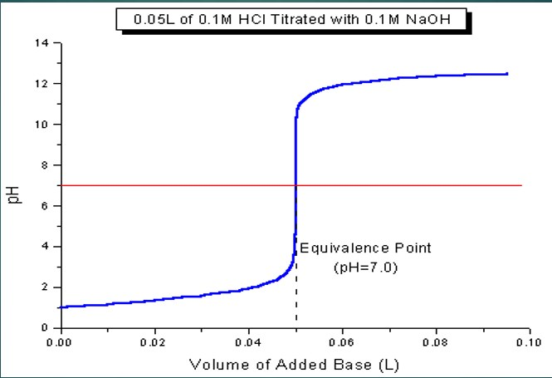

Strong acid with weak base

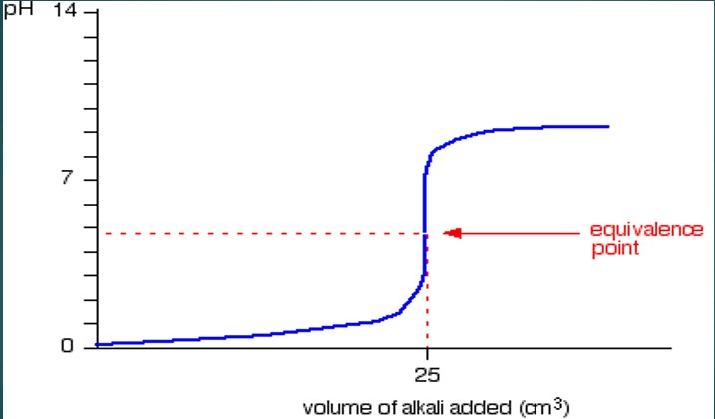

Weak acid with strong base
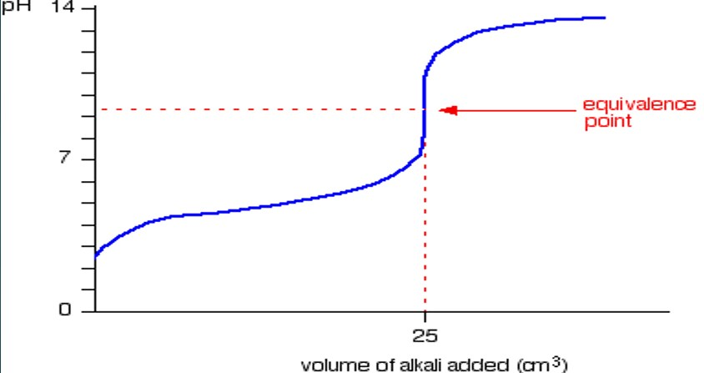

Chapter 6
Redox Reactions

Involve the transfer of electrons from 1 species to another.

Oxidation-
- The loss of electrons
- Gain of oxygen
- Loss of hydrogen
- Increase in Oxidation number

Reduction-
- The gain of electrons
- Loss of oxygen
- Gain of hydrogen
- Decrease in oxidation number

Oxidising agent or oxidant: species that is reduced, causes substance to be oxidised
Reducing agent or reductant: species that is oxidised, causes a substance to be reduced

Oxidation Numbers

Species | Oxidation Number
Atoms in the elemental state | 0
Monatomic ions  (Groups I metals in combined state)  (Groups II metals in combined state) | Charge on the ion  +1  +2
Oxygen in combined state  Exception 1: peroxides eg: Na₂O₂, H₂O₂  Exception 2: F₂O | -2  -1  +2
Hydrogen in combined state  Exception: metal hydrides eg: NaH | +1  -1
For polyatomic species the sum of the oxidation numbers | Charge on the ion

Half-equations
- Oxidation half-equation shows species which is oxidised. Electrons are on the product side of the half-equation.
- Reduction half-equation shows species which is reduced. Electrons on reactant side of half-equation

Balancing Half-equations
- Use oxidation numbers to identify the element being oxidised or reduced
- Write skeleton equation (reactant → product)
- Balance number of atoms of element being oxidised or reduced
- Balance oxygen atom by adding H₂O
- Balance hydrogen atoms by adding H⁺
- Balance charge by adding electrons to the side that is most positive
Balancing using half-equations
- Half equations can be added so that the number of electrons for each half equations is equal.
- When the 2 half-equations are added together electrons don’t appear in overall redox equation.

